**T.Y .BTech (ECM) – Image Processing**

**Tutorial No -1 : Basic Digital Image-I**

* **Problem Statement** – Write a program to extract some useful information about the image using Matlab
* **Objective:** To study the Image Processing concept.
* **Tools Required:** MATLAB
* **Theory:** Digital images play an important role both in daily life applications as well as in the areas of research technology. Digital image processing refers to the manipulation of an image by means of a processor. The different elements of an image processing system include image acquisition, image storage, image processing and display
* **Specify the syntax used in MATLAB for the following operation**.

1. Reading images
2. Image display
3. Image resize
4. Image crop
5. Image information
6. Image write
7. Displaying detailed information about pixel values

* **Conclusion**:
* **Discussion** –

1. What are the different formats of the image?

2. Discuss different image data classes.

***Program :***

% Read in an image

clear all;

img = imread('Image.png');

imshow('Image.png');

% Get the size of the image

[height, width, channels] = size(img);

% Resize the image to 50% of its original size

resized_img = imresize(img, 0.5);

% Display the resized image

figure;

imshow(resized_img);

% Crop the image

cropped_img = imcrop(img, [50 50 200 200]);

% Display the cropped image

figure;

imshow(cropped_img);

% Save the resized and cropped images

imwrite(resized_img, 'resized_example.jpg');

imwrite(cropped_img, 'cropped_example.jpg');

imtool(img)

imfinfo('Image.png')

***Results:***

***Output of*** [height, width, channels] = size(img)

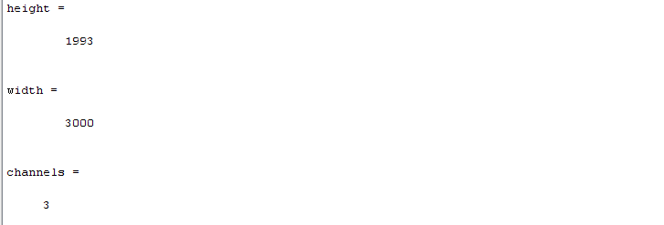

***Output of*** imshow('Tulips.jpg');

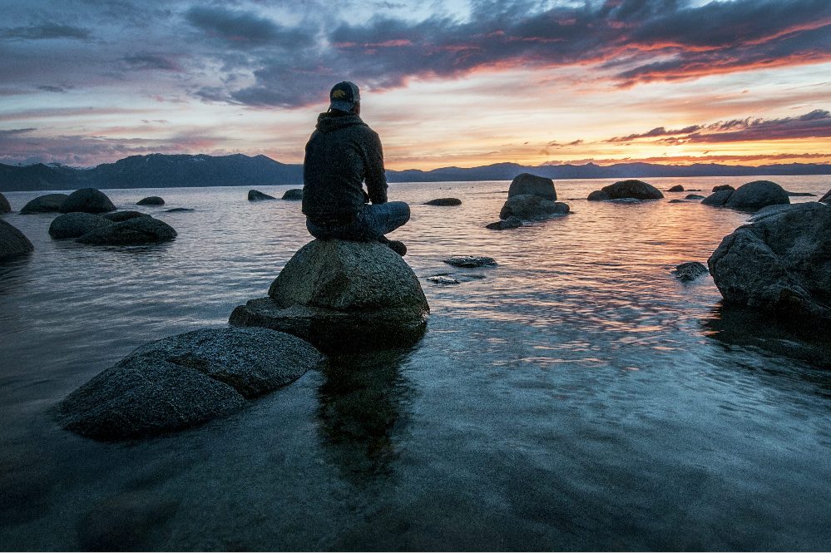

**Original Image**

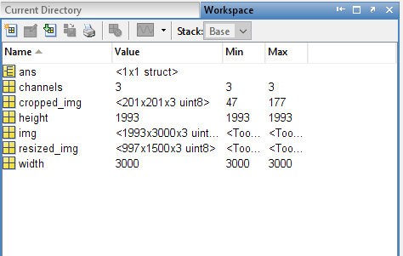

***Output of*** resized_img = imresize(img, 0.5);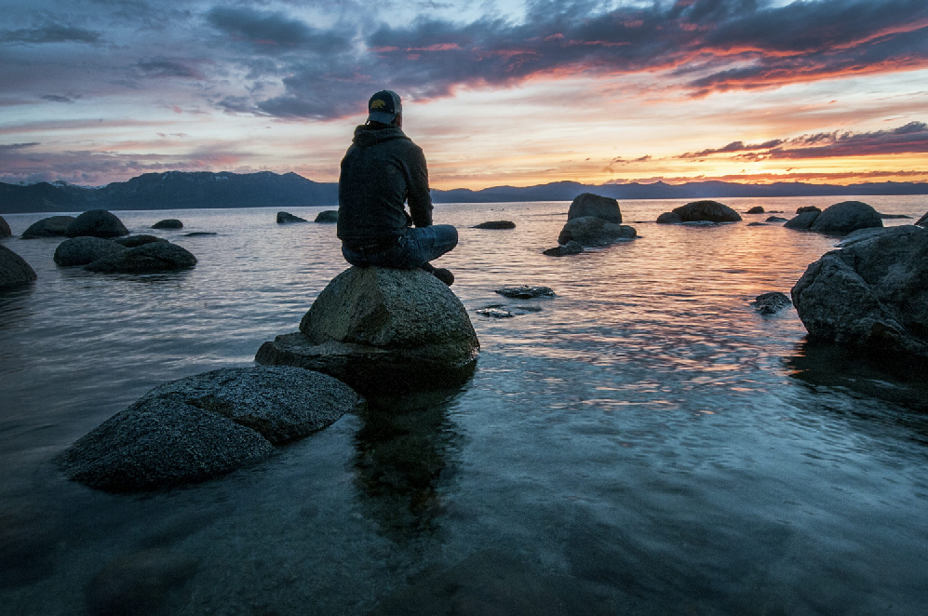

**Resized Image**

***Output of*** cropped_img = imcrop(img, [50 50 200 200]);

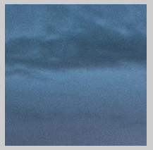

**Copped Image**

***Output of*** imtool(img)

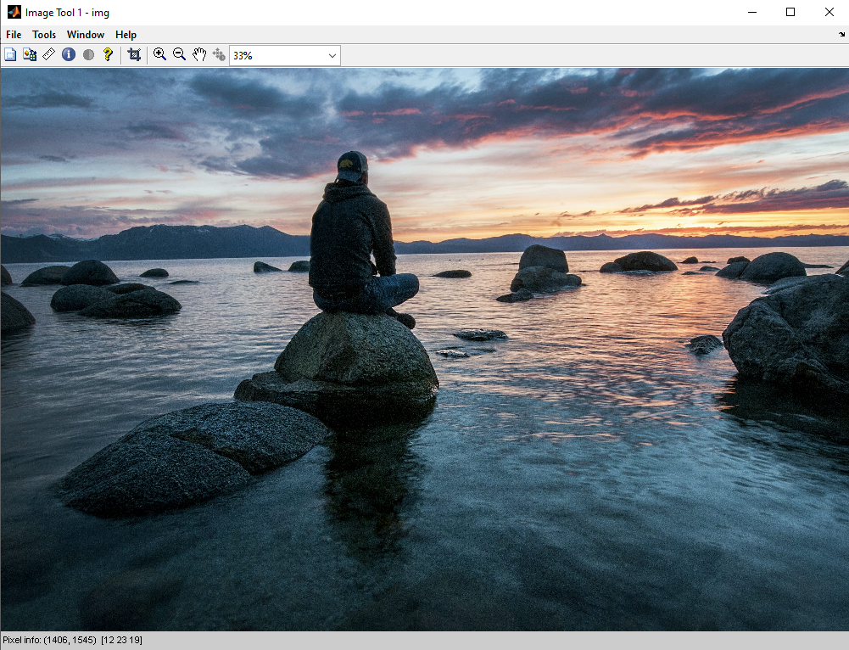

***Output of*** imfinfo

